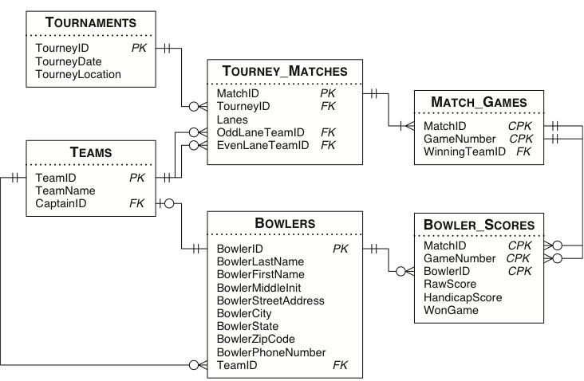

4. Show name of teams which won a game of a match but lose that match (1 point)
5. Show name of teams which only play in odd lane (1 point)

